CASE STUDY- THE FLIP SIDE OF SEGMENTATION

# MARKETING ANALYTICS RENU DEEPYA ISKA| 03/08/2024

## QUESTION 1

Read the questionnaire in Appendix 2 carefully. Do you, like Anand, have any concerns? Highlight any potential issues with the construction of the questions and/or the scales used to collect the responses. Recommend changes, if you consider them necessary, to the questionnaire.

Answer:

After a careful examination of the questionnaire provided in Appendix 2 of the case study, highlighting any potential issues with the construction of the questions and/or the scales used to collect the responses, and recommending changes if necessary. Here analyzing each aspect of the questionnaire:

Question Wording and Ambiguity:

Some questions may suffer from ambiguity or lack of clarity. For instance, in question D1, respondents are asked about the B-school they are studying in, but the term "B-school" may not be universally understood, especially outside of certain regions or industries. Clarifying the term or providing examples could enhance comprehension.

Response Options:

The scale used in questions Q1 to Q4 consists of five options: Strongly Disagree, Disagree, Neither, Agree, and Strongly Agree. While this scale is common, it lacks a neutral option, which could affect the accuracy of responses, especially for respondents who feel neutral about a statement. Adding a neutral option (e.g., Neither Agree nor Disagree) may improve response quality.

Potential Response Bias:

Some questions might lead respondents to answer in a certain way due to social desirability bias. For example, in Q1, the statement implies that having certifications on a resume is positive, potentially biasing responses towards agreement. Rewording questions to be more neutral or balanced could mitigate this bias.

Demographic Section Length:

The demographic section (D1 to D7) contains several questions about respondent characteristics, such as B-school ranking, work experience, and undergraduate degree. While these questions provide valuable context, the length of the section may discourage respondents from completing the survey, especially if they perceive it as burdensome. Streamlining these questions or offering incentives for completion could improve response rates.

Based on these observations, the following recommendations are proposed for improving the questionnaire:

* Clarify ambiguous terms and provide examples where necessary to enhance comprehension.
* Expand the response options to include a neutral option in the Likert scale to capture neutral attitudes accurately.
* Rephrase questions to minimize potential response bias and ensure neutrality.
* Streamline the demographic section to reduce respondent burden and improve completion rates.

Implementing these recommendations could enhance the clarity, accuracy, and completeness of the survey data, ultimately leading to more robust segmentation analysis and actionable insights for FLIP.

## Question 2

Run a cluster analysis (without discriminant analysis) on data. Identify the appropriate number of clusters and name each cluster.

Answer:

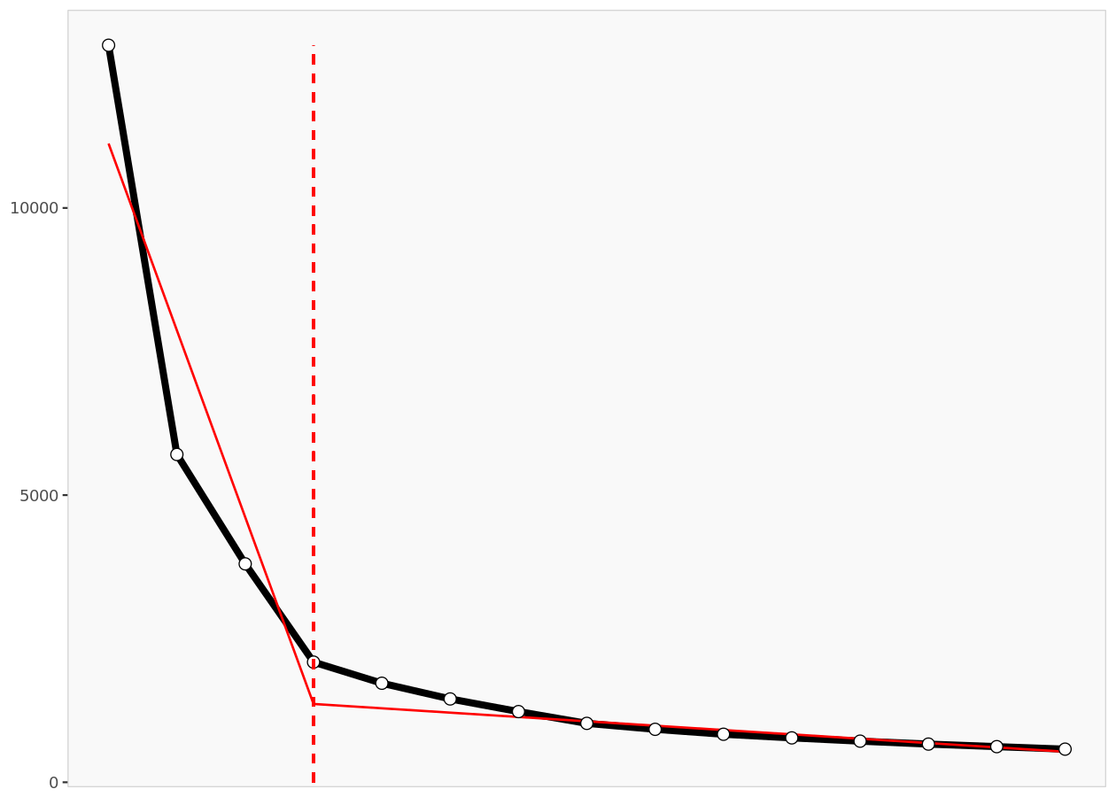

The decision to use a 4-segment solution in the cluster analysis is based on statistical fit, managerial relevance, and targetability. It strikes a balance between capturing data variability, aligning with organizational strategies, and providing distinct and manageable segments for targeted marketing efforts.

Based on the Enginius segmentation, a cluster analysis suggests that four distinct clusters are appropriate. Here are the identified clusters along with their characteristics:

Premier B-School Experienced Professionals:

* Members of this cluster predominantly attended premier B-schools.
* They possess significant work experience, with an average total work experience of 11.6 years.
* They have relevant work experience in the banking and financial services (BFS) sector.
* Major specialization in systems and minor specialization in marketing are common among this cluster.
* They hold undergraduate degrees in engineering or technology (BE/BTech).
* They typically belong to the top 25 percentile in their class.
* These individuals show a strong inclination towards showcasing their abilities on their resumes and have high expectations for campus placement prospects.
* They exhibit moderate preferences for practical insights, e-learning, and attending finance workshops.

Unknown B-School Career Switchers:

* Members of this cluster have a mix of educational backgrounds, including some from unknown B-schools.
* They have extensive work experience, with an average total work experience of 44.6 years, indicating a significant number of mid-career professionals.
* However, they lack relevant work experience in the BFS sector.
* Specializations vary, with a mix of systems and marketing.
* They hold undergraduate degrees in a variety of fields, including engineering, commerce, and arts.
* These individuals are diverse in terms of percentile in class, with some belonging to the top 10 percentile.
* They exhibit a high interest in job switching, suggesting a propensity for career change or advancement.
* Preferences for practical insights and campus placement prospects are moderate compared to other clusters.

Diverse Backgrounds with Moderate Preferences:

* This cluster comprises individuals with diverse educational backgrounds, including premier and unknown B-schools.
* They have moderate levels of work experience, with an average total work experience of 12.8 years.
* Relevant work experience in the BFS sector varies within this cluster.
* Specializations are diverse, including systems and marketing.
* Undergraduate degrees range from engineering and commerce to arts.
* Percentile in class distribution is varied, with representation from the top 10 percentile to the top 25 percentile.
* Preferences across various factors such as campus placement prospects, practical insights, and e-learning are moderate compared to other clusters.

Engineering Graduates with Varied Preferences:

* Members of this cluster predominantly hold undergraduate degrees in engineering or technology.
* They have moderate work experience, with an average total work experience of 22.8 years.
* Relevant work experience in the BFS sector is limited within this cluster.
* Specializations vary, with a mix of systems and marketing.
* Percentile in class distribution ranges from the top 10 percentile to the top 25 percentile.
* Preferences for factors such as job switching, convenience, and price sensitivity vary within this cluster.
* Individuals in this cluster exhibit relatively higher preferences for e-learning and finance workshops compared to other clusters.

These identified clusters provide insights into the diverse profiles and preferences of individuals within the dataset. The cluster names reflect their educational backgrounds, work experience, and preferences, allowing for a clear understanding of the segmentation outcomes.

## Question 3

Re-run the cluster analysis using the number of clusters you chose in Question 2, together with a discriminant analysis. Using the output from the discriminant analysis, describe each segment.

Answer:

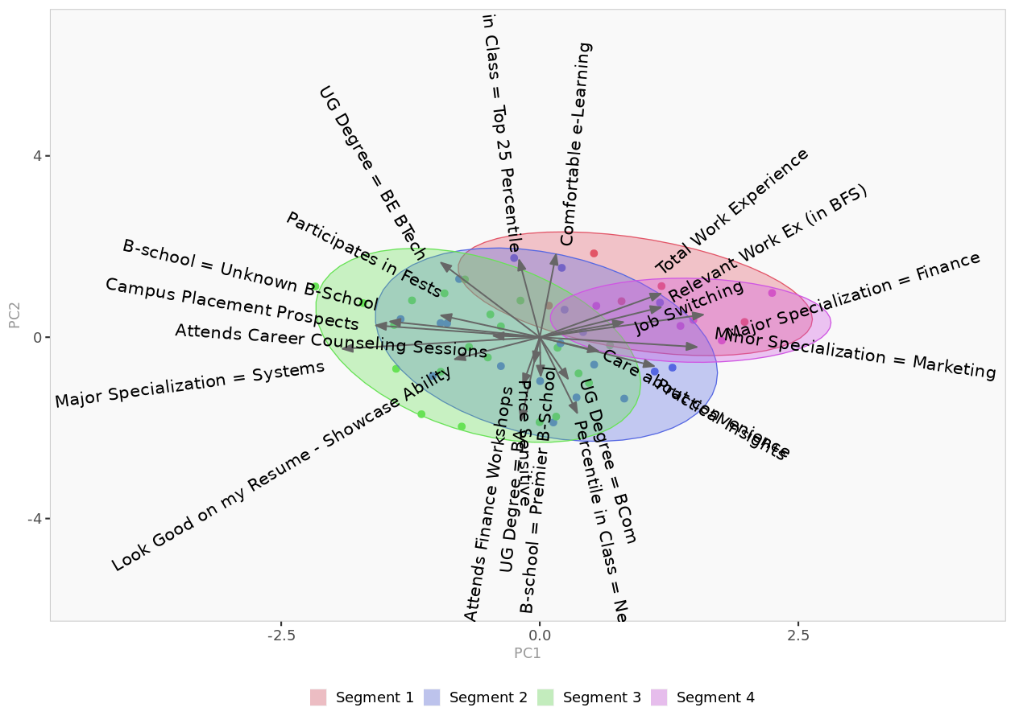

Based on the output from the discriminant analysis, each segment can be described as follows:

Segment 1 (Achievers):

* This segment consists of individuals who prioritize showcasing their abilities and seek practical insights to excel in their careers.
* They are highly comfortable with e-learning and prioritize campus placement prospects.
* The discriminant analysis highlights variables such as "Look Good on my Resume - Showcase Ability" and "Campus Placement Prospects" as significant discriminators for this segment.

Segment 2 (Experienced Professionals):

* Individuals in this segment have extensive work experience, particularly in the BFS sector.
* They prioritize career advancement opportunities and seek guidance through career counseling sessions.
* Discriminant analysis emphasizes variables like "Total Work Experience" and "Relevant Work Ex (in BFS)" as significant discriminators for this segment.

Segment 3 (High Achievers):

* This segment includes individuals who are top percentile performers in their class and are proactive in seeking career-related guidance.
* They prioritize practical insights and campus placement prospects, aiming for high career success.
* Discriminant analysis highlights variables such as "Percentile in Class = Top 25 Percentile" and "Campus Placement Prospects" as significant discriminators for this segment.

Segment 4 (Savvy Learners):

* Individuals in this segment are characterized by their active participation in finance workshops and comfort with e-learning.
* They are price-sensitive and seek practical insights to enhance their skills and career prospects.
* Discriminant analysis emphasizes variables like "Attends Finance Workshops" and "Comfortable e-Learning" as significant discriminators for this segment.
* These descriptions are derived from the discriminant analysis, which identifies the key variables that differentiate each segment from the others.

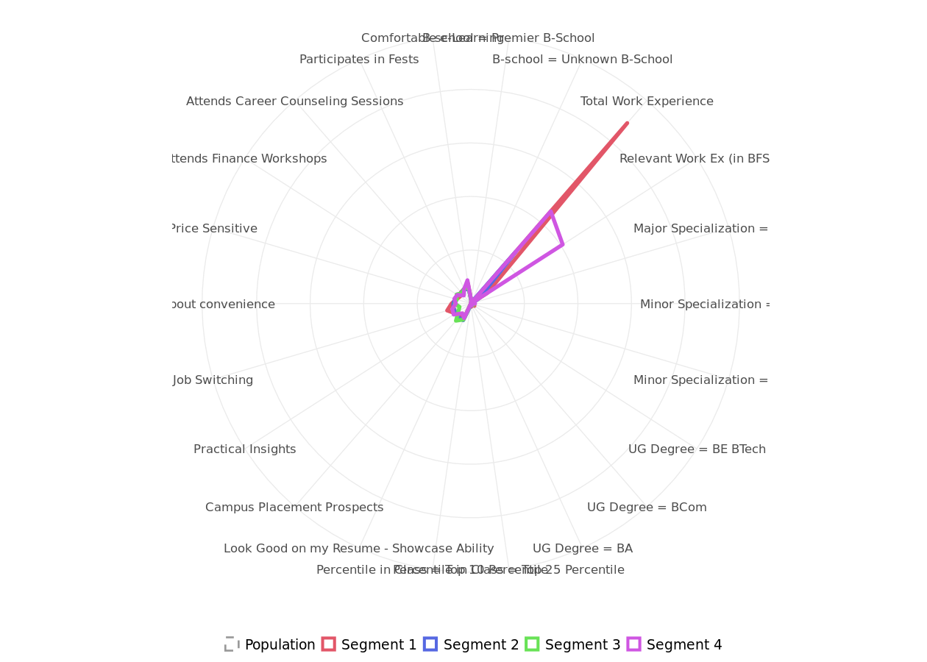

## Question 4

What are the next steps you would recommend for FLIP?

Answer:

Based on the segmentation analysis and the case study of FLIP, here are some recommended next steps to further enhance the business:

* Hyper-Personalized Marketing Campaigns: Utilize advanced data analytics and machine learning algorithms to create hyper-personalized marketing campaigns for each segment. By leveraging customer data such as browsing behavior, purchase history, and demographic information, FLIP can deliver targeted messages and offers that resonate with each segment's unique preferences and needs.
* Agile Product Development: Implement an agile product development approach to quickly iterate and refine FLIP's offerings based on segment-specific feedback. Collaborate closely with customers through co-creation sessions, beta testing, and feedback loops to ensure that new features and enhancements align with their evolving expectations.
* 360-Degree Customer Engagement: Adopt a holistic approach to customer engagement by integrating multiple touchpoints across online and offline channels. Implement omnichannel marketing strategies that seamlessly transition customers between digital platforms, physical stores, and customer support channels to deliver a unified and consistent experience at every interaction.
* Localized Market Expansion: Identify key geographic regions or niche markets with high growth potential and develop localized marketing strategies tailored to the unique preferences and cultural nuances of each market. Partner with local influencers, community organizations, and businesses to establish a strong presence and build brand credibility in these markets.
* Ecosystem Partnerships: Forge strategic partnerships with complementary businesses, service providers, and technology platforms to create an integrated ecosystem that enhances FLIP's value proposition and extends its reach to new customer segments. Explore opportunities to collaborate with fintech startups, educational institutions, and lifestyle brands to offer bundled services or loyalty programs that appeal to diverse customer segments.
* Predictive Analytics for Customer Retention: Implement predictive analytics models to forecast customer churn and proactively identify at-risk customers within each segment. Develop targeted retention initiatives, such as personalized incentives, loyalty rewards, and exclusive offers, to increase customer lifetime value and foster long-term loyalty.
* Continuous Learning and Innovation: Cultivate a culture of continuous learning and innovation within FLIP's organization by encouraging cross-functional collaboration, knowledge sharing, and experimentation. Establish dedicated innovation labs or incubation programs to incubate new ideas, prototype innovative solutions, and test emerging technologies that have the potential to disrupt the market and create new opportunities for growth.
* Brand Storytelling and Advocacy: Elevate FLIP's brand storytelling efforts to connect with customers on a deeper emotional level and foster brand advocacy within each segment. Develop compelling narratives that highlight FLIP's mission, values, and impact on customers' lives, and leverage user-generated content, testimonials, and case studies to amplify positive word-of-mouth and social proof.
* Sustainability and Social Responsibility: Integrate sustainability and social responsibility initiatives into FLIP's business practices to appeal to socially conscious consumers and align with the values of each segment. Implement environmentally friendly practices, ethical sourcing standards, and community engagement programs that demonstrate FLIP's commitment to making a positive difference in the world.
* Data Privacy and Security: Prioritize data privacy and security measures to safeguard customer information and build trust among FLIP's customer base. Implement robust cybersecurity protocols, compliance frameworks, and transparent data governance practices to ensure that customer data is protected against unauthorized access, breaches, and misuse.
* By embracing these next steps and continuously iterating on its strategies, FLIP can differentiate itself in the competitive landscape, foster deeper customer relationships, and drive sustainable growth and profitability in the long term.